**Exercise 14**

*Non-HTTP, non text, micro-integration*

**Prior Knowledge**

**Objectives**

In this lab we are going to explore some alternatives to what we’ve covered so far.

We are going to use a message pub/sub protocol (MQTT) with a binary payt

**Software Requirements**

(see separate document for installation of these)

* Java Development Kit 8
* Gradle build system
* Jetty and Jersey
* Eclipse Luna and Buildship
* curl
* Google Chrome/Chromium plus Chrome Advanced REST extension
* Swagger UI

**Overview**

Swagger - also now known as the Open API Initiative specification - is a simple JSON model for describing RESTful services.

We are going to use some Java tools to create a Swagger description of our API and then use the Swagger tooling to view this.

Steps

1. Start with your POResourceMS directory from Exercise 7.
2. Edit the build.gradle to add the following new dependency:  
     
   compile 'io.swagger:swagger-jersey2-jaxrs:1.5.9'
3. Go to the project and do a Refresh Gradle Project:  
   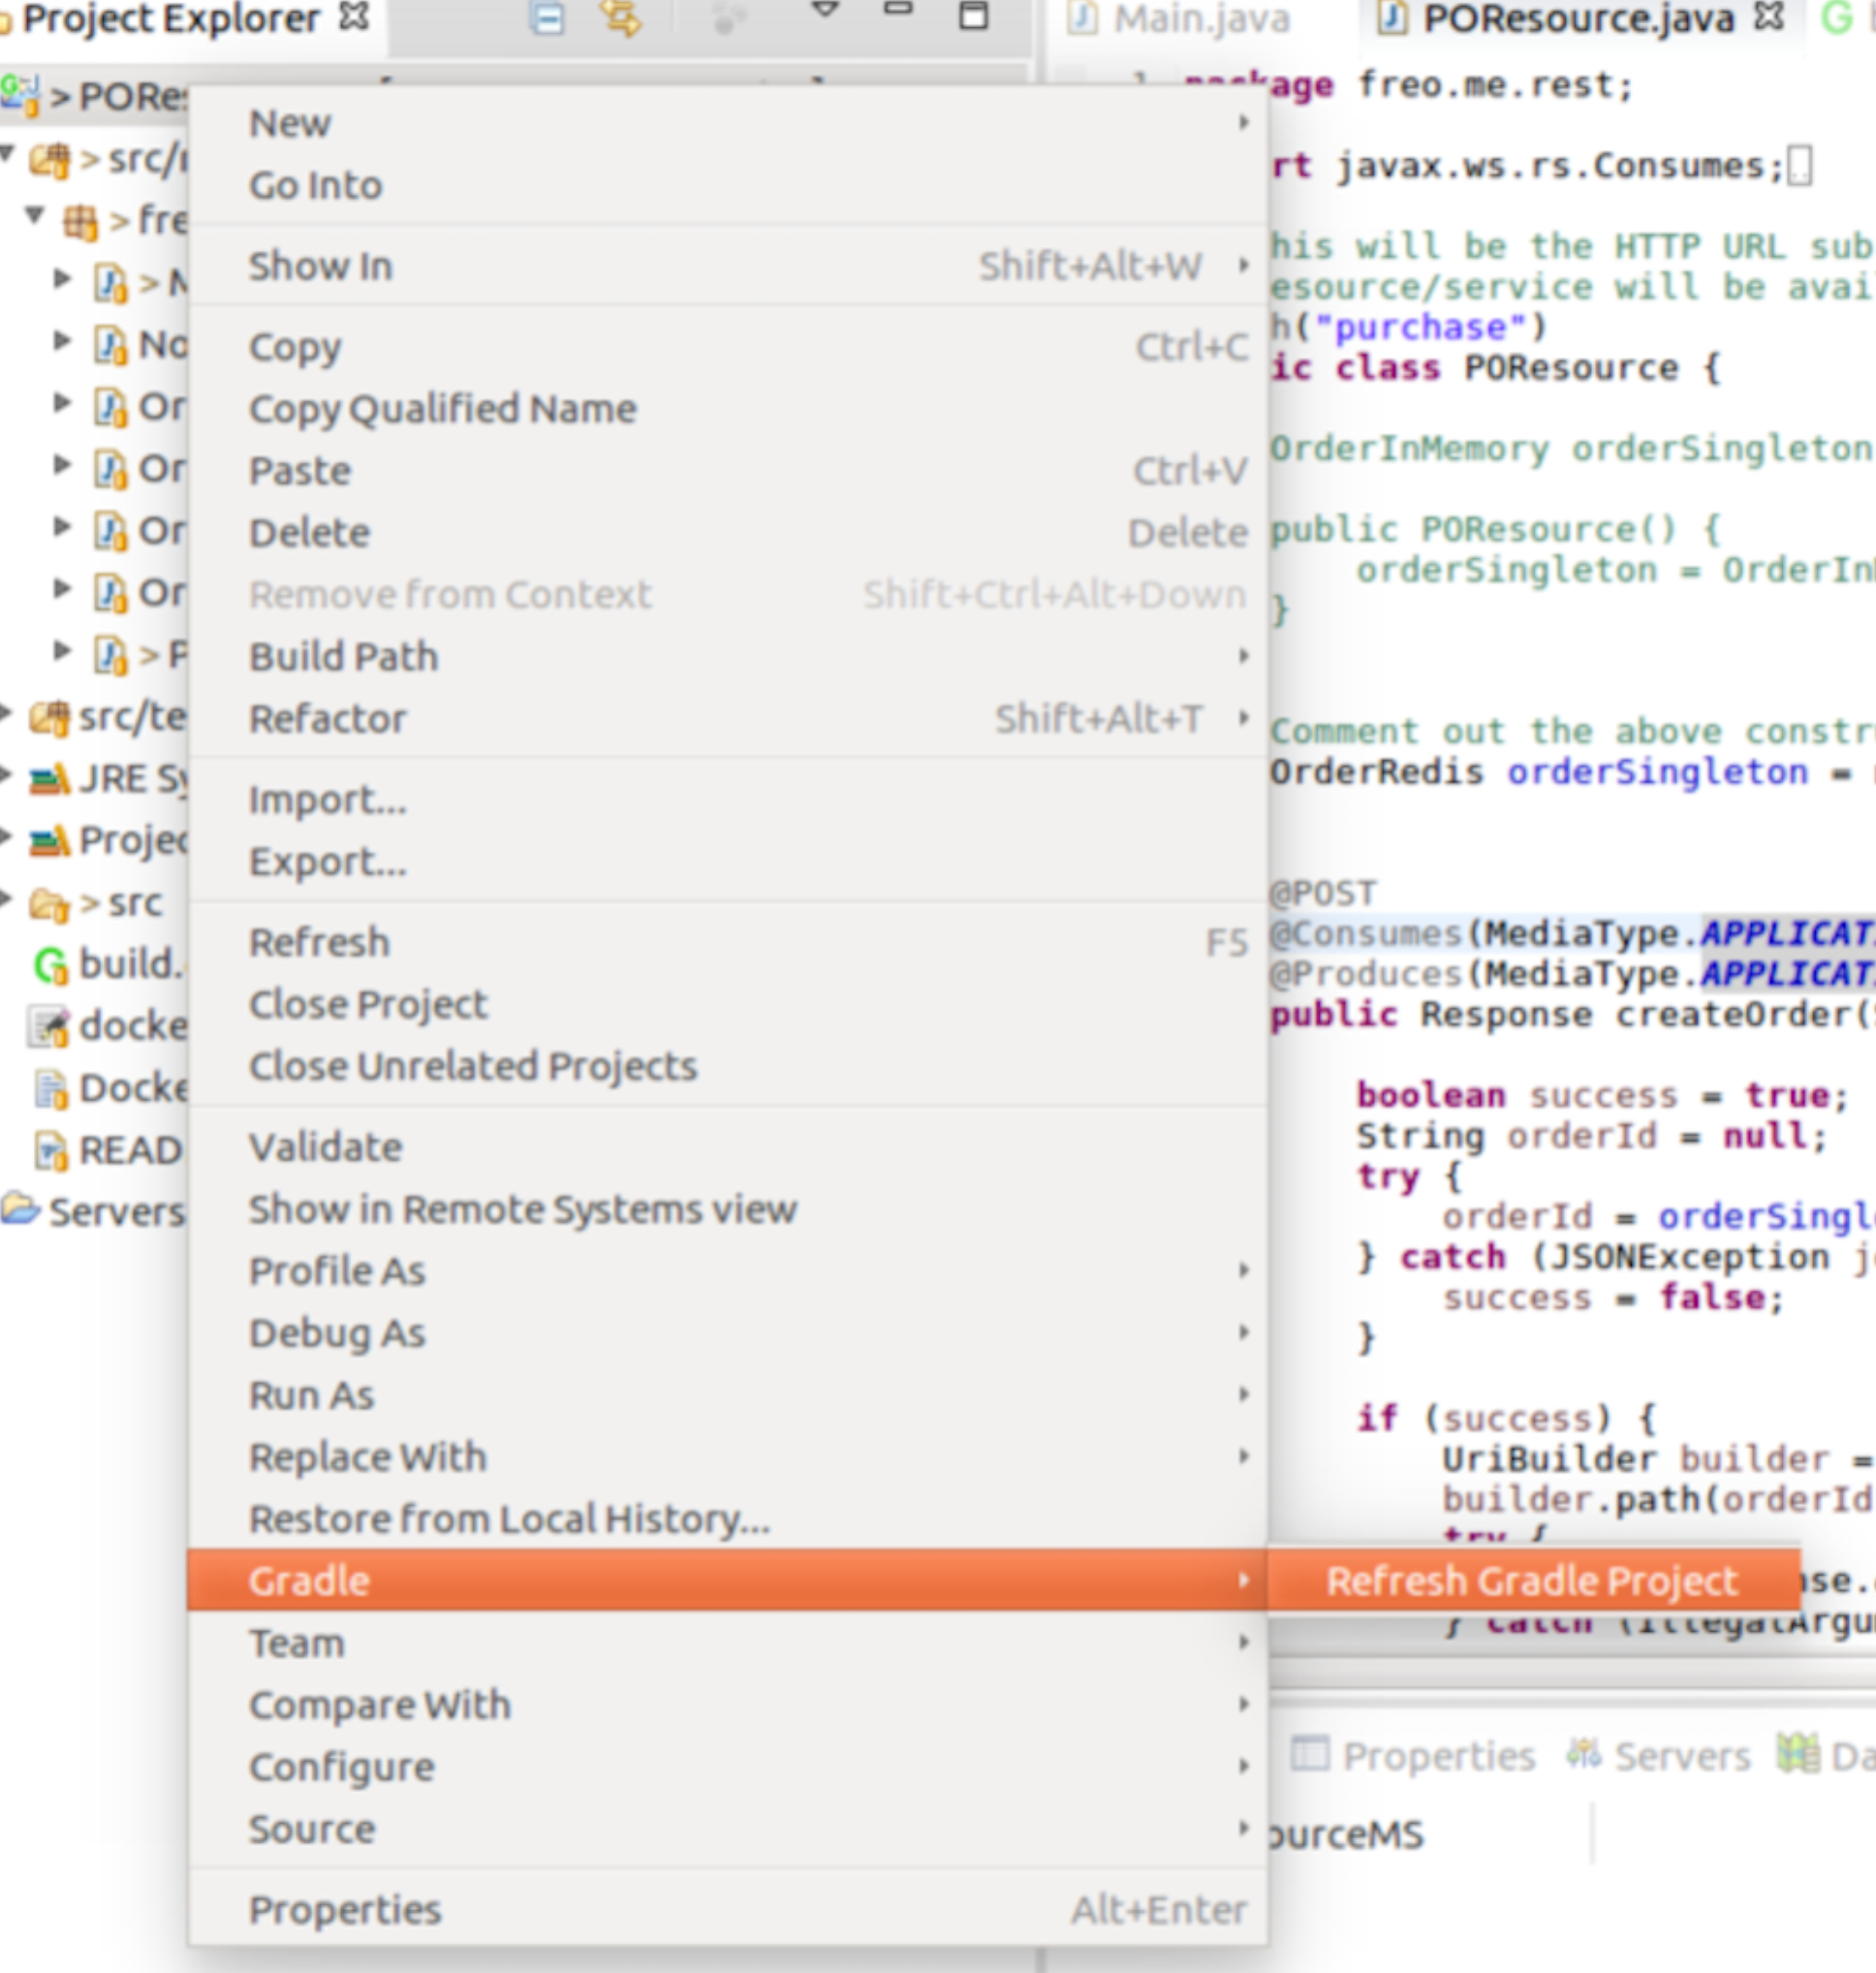
4. Go to the POResource.java and add a second annotation to the class just above @Path:  
   @Api(“purchase”)  
     
   Eclipse should automatically add the swagger package import.
5. We now need to tell the JAX-RS system about Swagger and get Swagger’s code running in our microservice.   
     
   *(Hint: if you are using a WAR file model instead, there is a completely different way of doing this, that is documented in the Swagger docs).*
6. Edit the Main.java  
     
   We need the constructor to look like this:

public Main() {

packages("freo.me.rest");

register(ApiListingResourceJSON.class);

register(SwaggerSerializers.class);

register(CORSFilter.class);

BeanConfig beanConfig = new BeanConfig();

beanConfig.setVersion("1.0.0");

beanConfig.setSchemes(new String[]{"http"});

beanConfig.setHost("localhost:8080");

beanConfig.setBasePath("/");

beanConfig.setResourcePackage("freo.me.rest");

beanConfig.setScan(true);

}

When you add this, the classes should all get resolved and the right imports added, with the exception of CORSFilter.class, which we will create in a minute.

Basically this is telling JAX-RS about some extra handlers that will be registered to add Swagger description to our code. The code will be automatically scanned and the Swagger description created from our existing JAX-RS annotations, but we need to give a little extra information (via the BeanConfig) to the system.

1. We also want the Swagger system to be able to generate a nice tool from our Swagger output. There are two ways to do this. We could embed the whole SwaggerUI into our app but this is complex and would make the lab overly confusing. Instead, we are going to run the Swagger UI and point it to our Swagger definition. This looks like a cross-site scripting attack, and so we need to use the CORS spec to avoid this problem.
2. To allow the SwaggerUI to read our JSON, we need to add some headers into the responses given by Jetty. We can do this with a JAX-RS filter.
3. Create a new Java class freo.me.rest.CORSFilter  
   Copy the following code into the class.  
   This is available at: <http://freo.me/ex7b-cors>

package freo.me.rest;

import java.io.IOException;

import javax.ws.rs.container.ContainerRequestContext;

import javax.ws.rs.container.ContainerResponseContext;

import javax.ws.rs.container.ContainerResponseFilter;

import javax.ws.rs.core.MultivaluedMap;

public class CORSFilter

implements ContainerResponseFilter {

public void filter(ContainerRequestContext requestContext,   
 ContainerResponseContext responseContext)

throws IOException {

MultivaluedMap<String, Object> headers = responseContext.getHeaders();

headers.add("Access-Control-Allow-Origin", "*");  
// headers.add("Access-Control-Allow-Origin", "http://wherever.org");   
// allows CORS requests only coming from wherever.org

headers.add("Access-Control-Allow-Methods",   
 "GET, POST, DELETE, PUT");

headers.add("Access-Control-Allow-Headers",   
 "X-Requested-With, Content-Type");

}

}

1. Rebuild the app using **gradle shadowJar**
2. Start the Jar using:  
   java -jar build/libs/POResourceMS-all.jar
3. You should see an additional line of log compared to before:  
   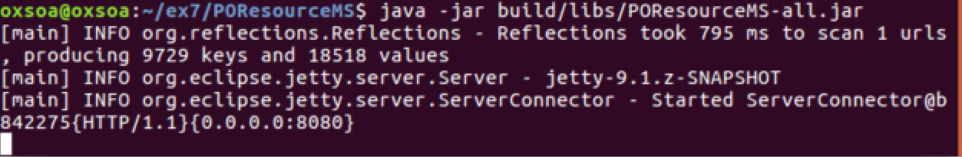
4. Browse to <http://localhost:8080>  
   If this has all worked properly, you should see a lot of JSON like this:  
   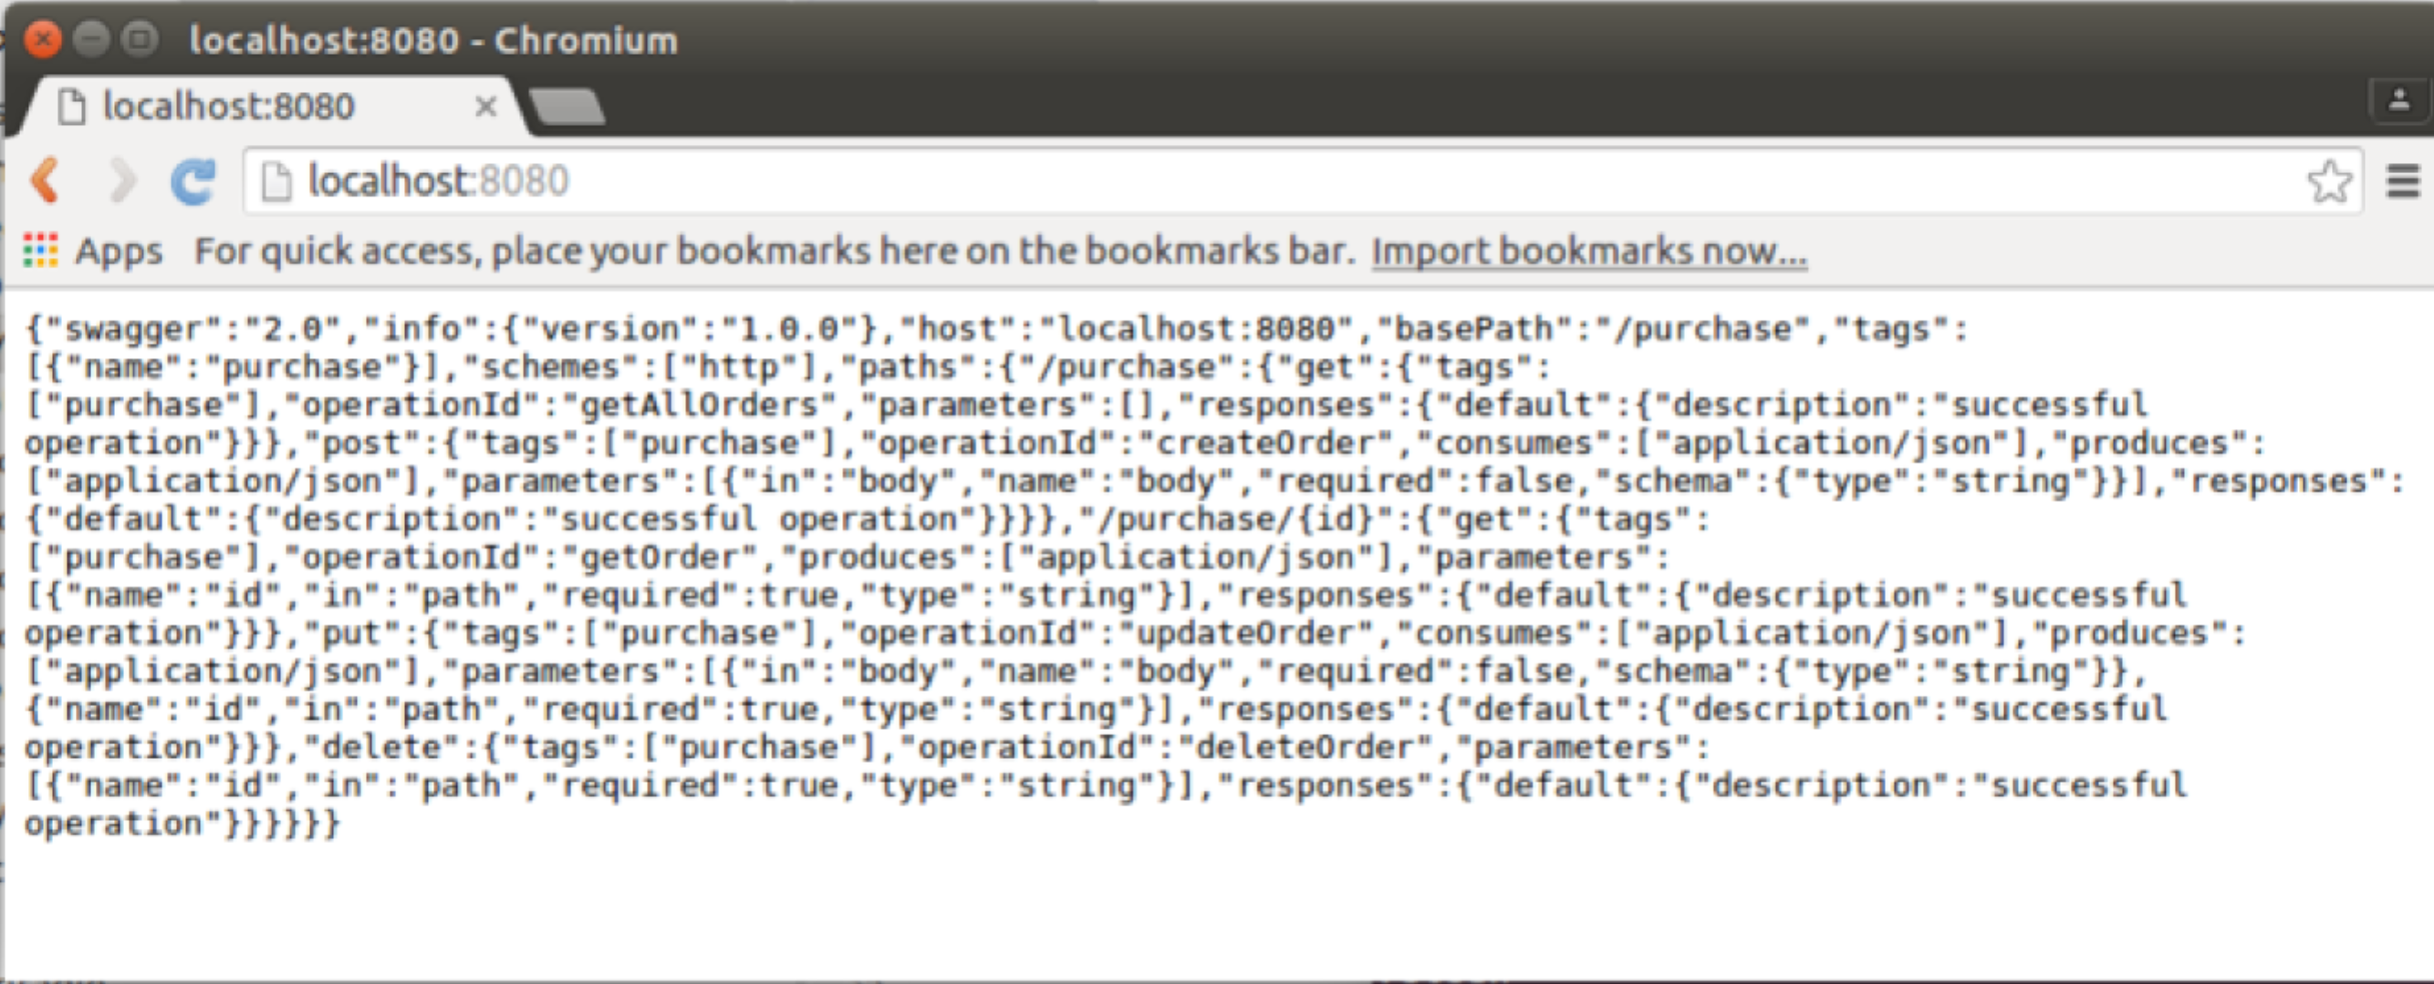
5. Go to the Swagger UI releases page:  
   <https://github.com/swagger-api/swagger-ui/releases>
6. Download the latest Swagger UI ZIP   
   ( <https://github.com/swagger-api/swagger-ui/archive/v2.1.4.zip> )
7. Unzip into the home directory:  
   cd ~  
   unzip ~/Downloads/swagger-ui-2.1.4.zip  
   cd ~/swagger-ui-2.1.4/dist
8. 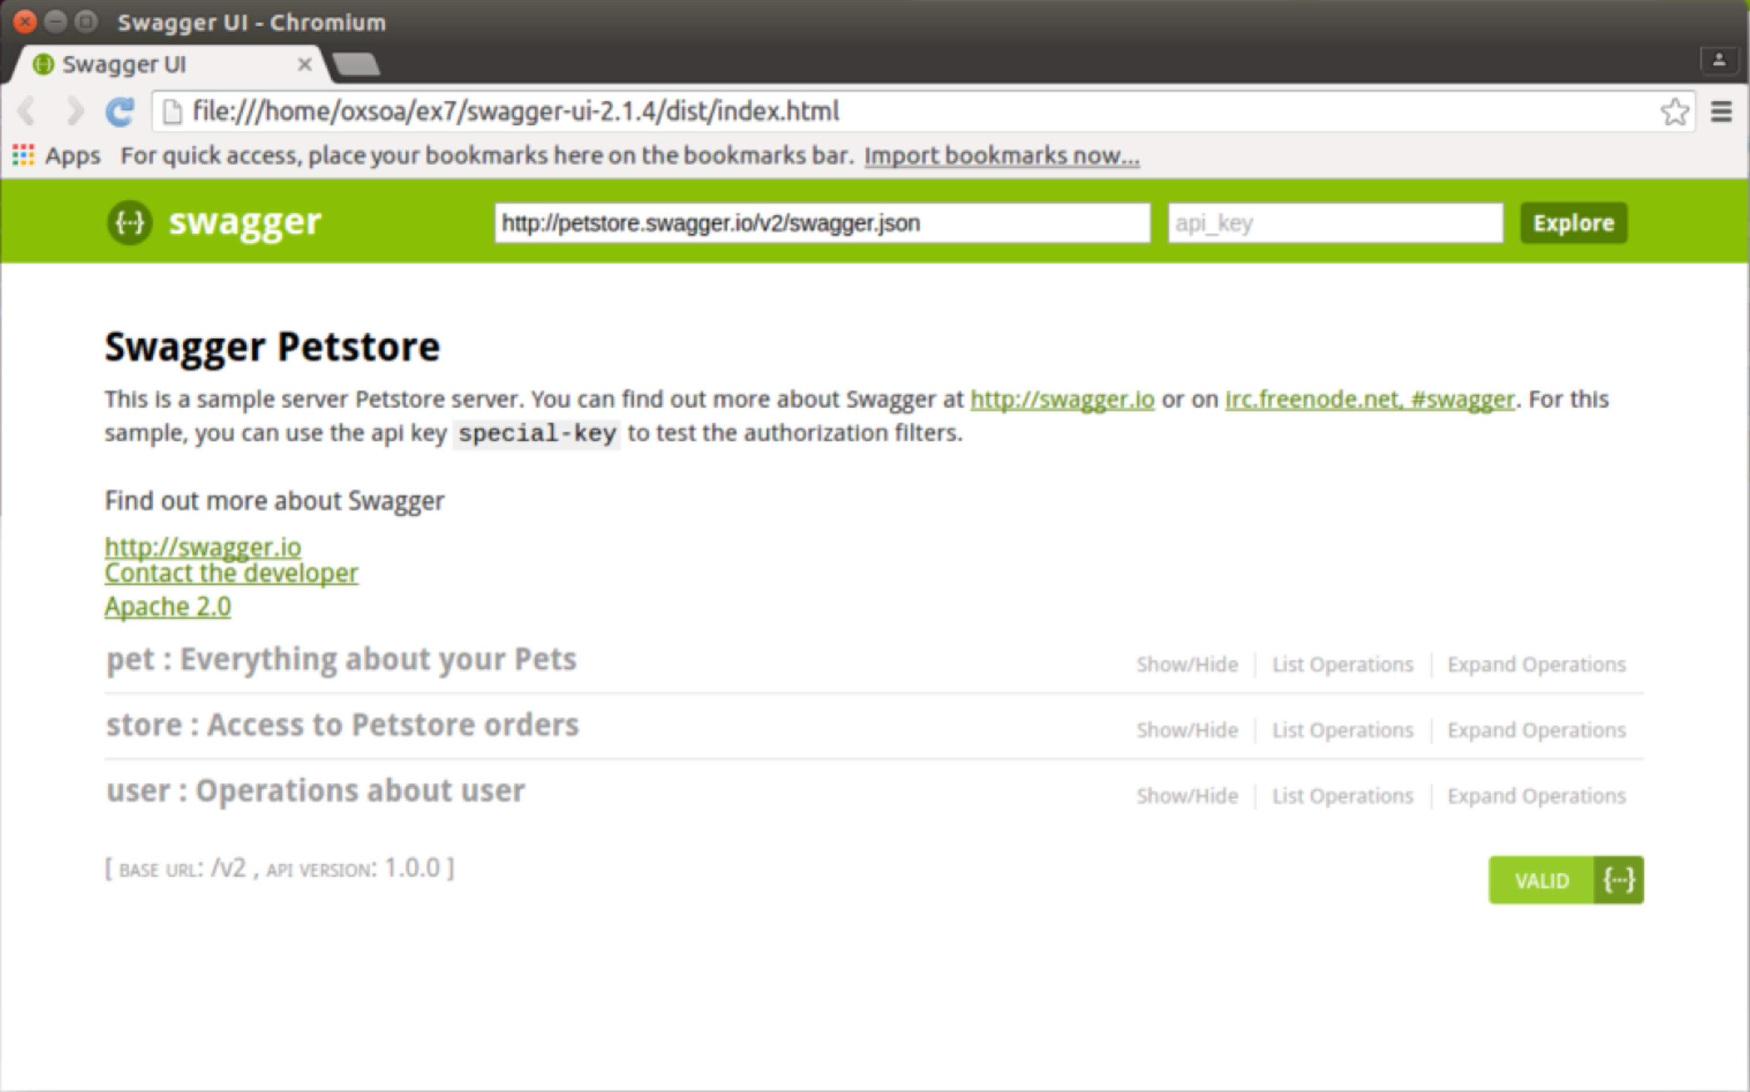Start up firefox browsing the index.html  
   firefox index.html
9. You should see a nice UI like this:
10. 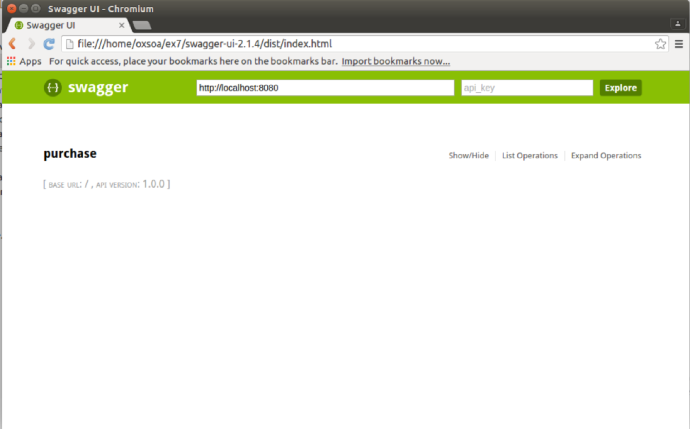In the URL box set the URL to be <http://localhost:8080>
11. You should see this:
12. Click on **purchase**
13. Explore the API and try it out using the Swagger test tool.
14. That’s all!